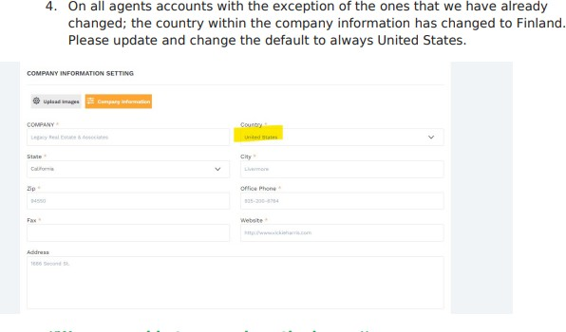

*Please see the Video in the link below. You will see that I had to change the country from “Finland” to United States.*

*And the State does not show, unless we try and save, then get the error that state is missing. That is the only time the state selections will appear.*

Link to Video Here: [https://virtualtourcafe.sharefile.com/public/share/web-](https://virtualtourcafe.sharefile.com/public/share/web-s0bd4dac9336e44e6aadd08b494f6da4e) [s0bd4dac9336e44e6aadd08b494f6da4e](https://virtualtourcafe.sharefile.com/public/share/web-s0bd4dac9336e44e6aadd08b494f6da4e)

1. Online order notification. When receiving online order notification via email. Can you add a section to show whether our client selected to Pay or Pay Later.
2. Even out the rectangular space for each agent, one is larger, than the others.

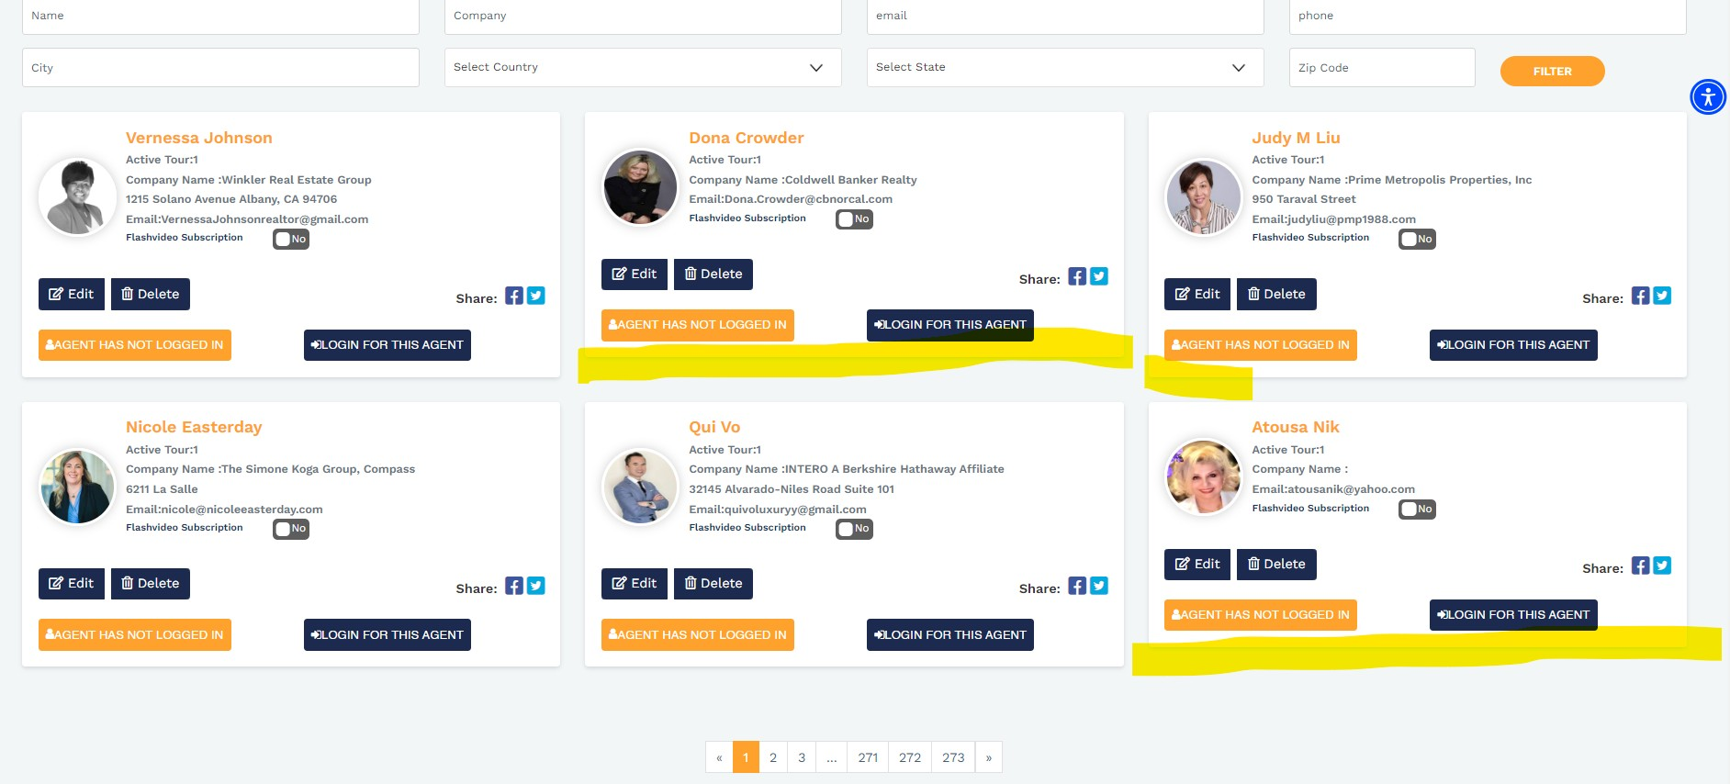

1. When changing the password – under settings, the changes don’t reflect on the Agent page. The only way to change it is by clicking on Edit on the agent page. See the screenshot below.

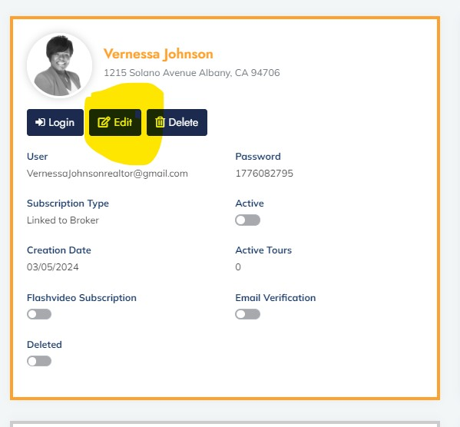

**but the credential section is also a HARD STOP when changing it from the edit section. Please remove this restriction.

